* **Title of the seminar:** "EXPLORING RESEARCH METHODS FOR AI-MEDIATED COMMUNICATION"
* **Type of the Activity:** Seminar on Research Methodology
* **Organizing Department/Committee:** SEMINAR SUB-COMMITTEE,
* **Date of the Activity:** 23-05-2023
* **Number of participants:** 46
* **Speakers:** DR. UMA SHANKAR PANDEY, ASSOCIATE PROFESSOR & HEAD, DEPARTMENT OF JOURNALISM & MASS COMMUNICATION, SURENDRANATH COLLEGE FOR WOMEN
* **Flyer:**

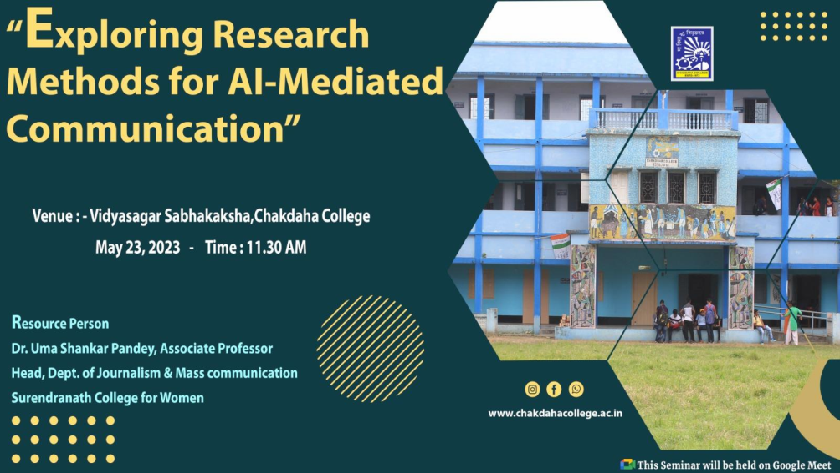

* **Outcome of the Seminar:**

A One Day State Level Seminar on “Exploring Research Methods for AI-Mediated Communication” was organized by Chakdaha College in blended mode on 23.05.2023. It started with the welcome address by Dr. Swagata DasMohanta, Honourable Principal of Chakdaha College. Dr. Uma Shankar Pandey, Head & Associate Professor, Department of Journalism and Mass Communication, Surendranath College for Women, was the Resource Person in the said seminar. He talked at length about Artificial Intelligence, Chat GPT, use of Artificial Intelligence by researchers of various disciplines etc. His talk was followed by an interesting interactive session where listeners (who were present both in online and offline modes) asked various questions, the answers to which were given by him. The audience was totally satisfied with his presentation. The target audience was glued to his simple yet informative delivery as it was replete with interesting examples from various fields with which they could easily identify themselves. The seminar ended with a vote of thanks by Sri Abhishek Chowdhury, Convenor of Seminar Subcommittee, Chakdaha College. The seminar was a grand success.

* 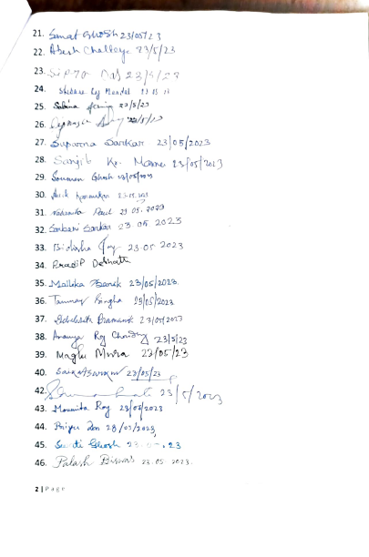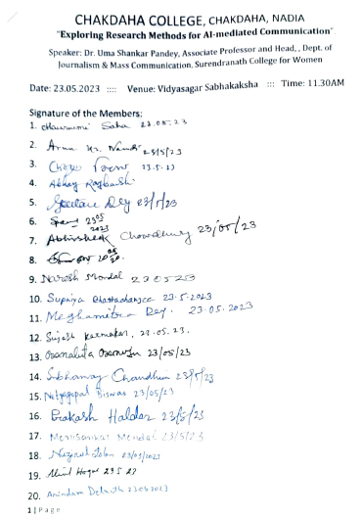**Attendance of the Seminar:** EXPLORING RESEARCH METHODS FOR AI-MEDIATED COMMUNICATION:
* J. **Photographs of the Programme:**

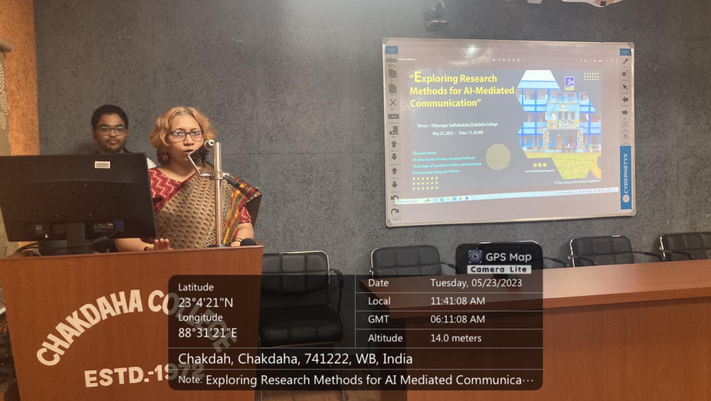

Principal Madam addressed the Inaugural speech

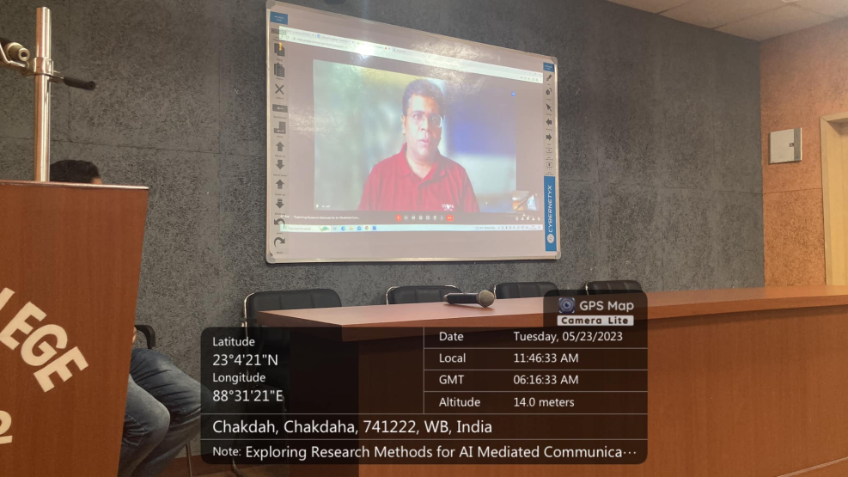

Online presentation of DR. UMA SHANKAR PANDEY

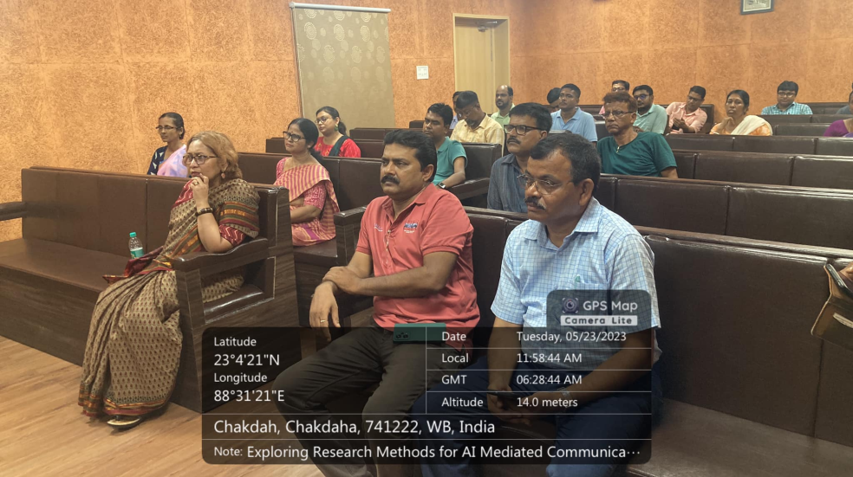

Audience of the Seminar

*Relevant Web Link:*

<https://www.facebook.com/chakdahacollegeoffice/posts/pfbid0yD7EYSxvFangzVJ5sJ3eWNKwihKoHUDM2K3oT2hDPkJFDi4fFzqWHYGi9VekocgKl>

<https://www.facebook.com/chakdahacollegeoffice/posts/pfbid02meZGeqzYdYziVdik58eGaoERgbaWxytNXUGU47Q4wUnmw1vof4CwDDCU932jh7LCl>